The Mabo Decision

The Wave Hill walk-out and subsequent ‘handing back’ of some Gurindji land opened the door to other land claims for First Nations People…

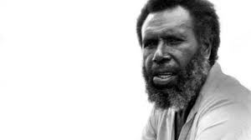
Eddie Mabo

Using:
https://aiatsis.gov.au/explore/mabo-case
and your own research answer the following questions:

- Who was Eddie Mabo?
- Where is Mer (Murray) Island? Draw a map.
- What was the Mabo Case about? When did this event happen?
- What was the ‘myth’ that the Mabo case overturned?
- What are the limitations of the Mabo decision? What lands can Aboriginal and Torres Strait Islander people claim?
- Research one other land claim by First Nations people- what was the outcome?

