The Stolen Generation
The Stolen Generations refers to a period in Australia’s history where Aboriginal children were removed from their families through government policies. This happened from the mid-1800s to the 1970s.
In the 1860s, Victoria became the first state to pass laws authorising Aboriginal children to be removed from their parents. Similar policies were later adopted by other states and territories – and by the federal government when it was established in the 1900s. For about a century, thousands of Aboriginal children were systematically taken from their families, communities and culture, many never to be returned. These children are known as the Stolen Generations survivors, or Stolen Children.
These children were taken by the police; from their homes; on their way to or from school. They were placed in over 480 institutions, adopted or fostered by non-Indigenous people and often subjected to abuse. The children were denied all access to their culture, they were not allowed to speak their language and they were punished if they did. The impacts of this are still being felt today.
https://healingfoundation.org.au/who-are-the-stolen-generations/
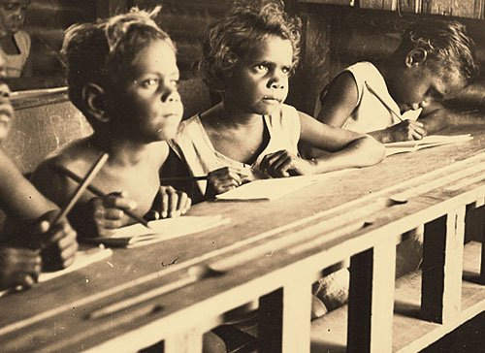

Listen to both songs, and choose one each day to answer the questions for. Refer to the Lyrics documents as needed.

Archie Roach ‘Took the children away’:
- What is your initial response to the song? How does it make you feel?
- How would you describe Archie Roach’s voice? What emotions does he convey in his voice alone? Are these emotions the same in every verse?
- Do you know what “Framingham” is? If not do some research to find out.
- What do the lines: “We'll give them what you can't give
Teach them how to really live” mean?
- How is the fourth verse different from the previous three? Which term below do you think most accurately describes it’s feeling? Why?
  - Complete
  - Hopeful
  - Regretful
  - Would you choose a different descriptor? Why?
Dan Sultan- ‘Roslyn’:
- What is your initial response to the song? How does it make you feel?
Using
- https://www.abc.net.au/local/stories/2008/01/20/2140080.htm
Find out from whose perspective is this song written?
- If Dan Sultan is 38 years old, estimate the approximate year his mum was taken away from her family.
- Explain the following lyric mean? “With the lord and a gun
They'll keep you safe from harm”.
- Why would they have told children that their parent were dead, or didn’t care about them?

