Geology and Geomorphology of the Australian Alps

Map of Australian Alps National Parks:
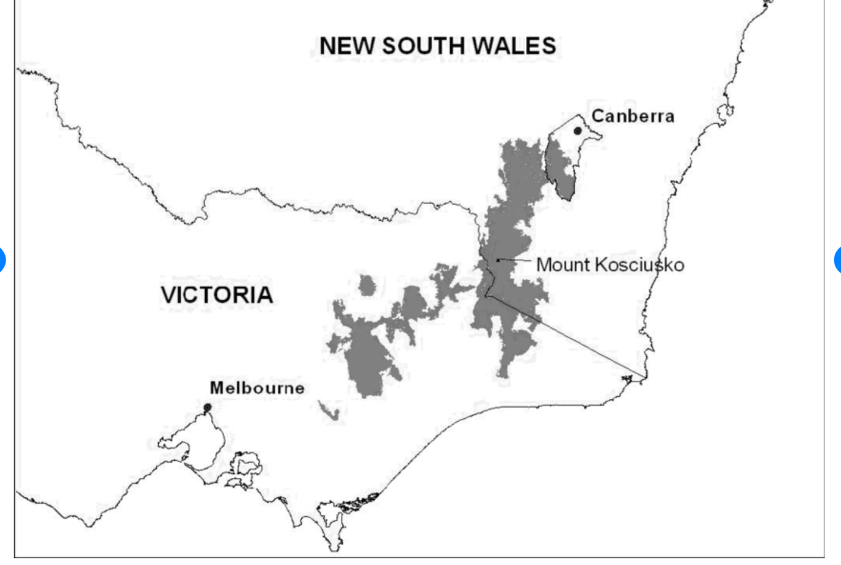

The Australian Alps- part of the Great Dividing Range.

There was a time of upheaval, mountain building and intrusions of igneous rocks long ago from the Cambrian to the Devonian periods. Some of these rocks still form parts of the Alps today.
These mountains were largely worn away over the next 200 million years.

The next period of change began about 130 mya when stirrings in the deep mantle began form a high plateau, breaking up eastern Gondwana. Australia began the long process of breaking away from Antarctica and Zealandia.
By 100 mya the plateau was possibly over 2000 m high in its highest area, the site of today's Australian Alps. Gondwana split apart along this line of magma upwelling, and a rift valley formed along the centre of the plateau.

See below a picture of Zealandia: an almost entirely submerged mass of
continental crust that subsided after breaking away from Gondwanaland 83–79 million years ago. The pink line outlines Zealandia.

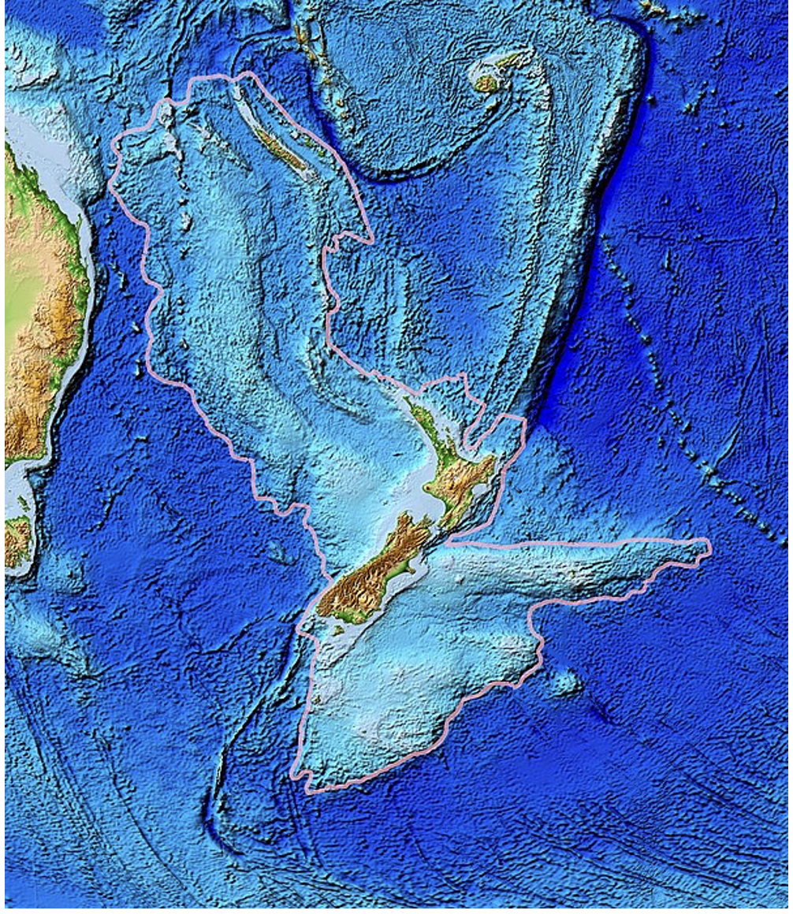

By 65 mya the Tasman Sea and Bass Strait were in their current configuration and the Australian Alps were probably not much higher than they are today.
Over the last 50 mya basalt lava has been erupted episodically over much of the alpine region. The lava came out of small volcanoes and flowed across the landscape and down valleys.
Most of the last 2 million years have been a time of global ice age, with ice caps forming on high ranges around the world, as well as at the poles. This cold period is known to geologists as the Pleistocene epoch.
Because Australia’s mountains are relatively low there is only evidence of glaciers in the very highest peaks of NSW, and Tasmania. (See photos below).
Blue Lake NSW
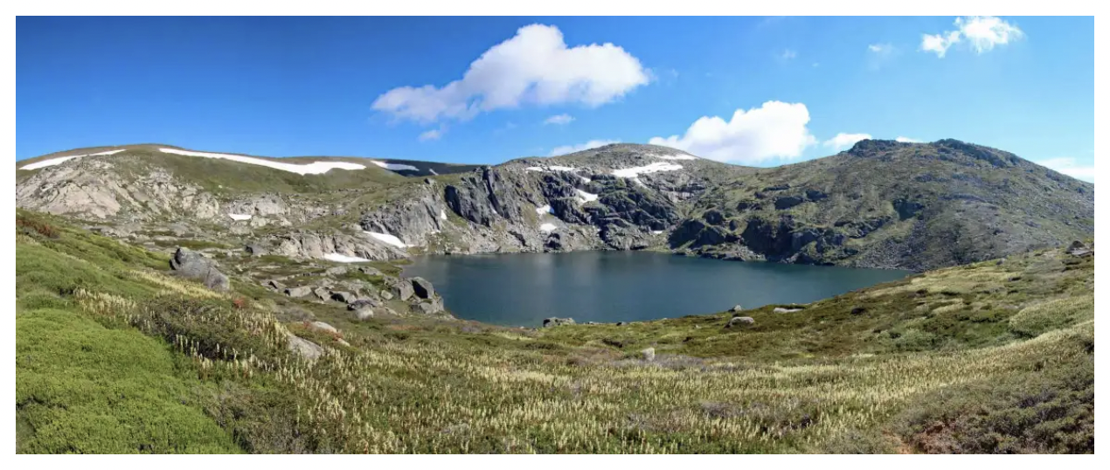

Cradle Mountain Tasmania
